Attendance Monitoring System Guide

In this Package

This package contains the following files:

1. add_firewall_inbound_rule.bat
2. Attendance Monitoring System.msi
3. Database scripts  
   a. 00.1 CREATE Database, Login, User, Table, SP.sql  
   b. 00.2 INSERT Level, Admin User.sql

Installation Overview

## System Requirements

These software components must be installed before installing AMS (minimum version).

|  |  |  |
| --- | --- | --- |
| Component | Version | Notes |
| Digital persona SDK |  |  |
|  |  |  |
| Microsoft .NET Framework | 4.6.1 | Link: <https://www.microsoft.com/en-us/download/details.aspx?id=49978> |
|  |  |  |
| Microsoft SQL Server 2017 Express | 14.0.1000.169 | Use **basic installation** Link: <https://www.microsoft.com/en-us/download/details.aspx?id=55994> |
|  |  |  |
| Take note of the instance name | | |
|  |  |  |
| SQL Server Management Studio | 17.6 | Install right after the MICROSOFT SQL SERVER 2017 EXPRESS Link: <https://docs.microsoft.com/en-us/sql/ssms/download-sql-server-management-studio-ssms> |

Pre-Installation

## SMS Setup

Enable developer options of the Android Smartphone:

1. Go to Settings
2. Click About Phone
3. Search for Build number, if not available Click Software info
4. Tap Build number seven times
5. Once activated, you will see a message that reads, “You are now a developer!”
6. Go back to Settings
7. Click Developer Options
8. Enable “Stay awake” and “USB debugging”

Setup Android Debug Bridge (ADB)

1. Download ADB file from this link: <https://developer.android.com/studio/releases/platform-tools.html>.
2. Extract the contents of this ZIP file
3. Go to the folder where the platform tools are extracted.
4. Open command prompt from this directory. This can be done by holding Shift and Right-clicking within the folder then click “Open command window here”.
5. Connect the Android smartphone to the computer with a USB cable. Change the USB mode to “File transfer (MTP)” in the Smartphone.
6. In the command prompt window, enter this command: **adb devices**
7. On your phone’s screen, you should see a prompt to allow or deny USB Debugging access. Tick Always allow from this computer then click OK.
8. Re-enter the command **adb devices**, if successful you should see the device’s serial number in the command prompt.

Change the Android’s SMS Limit

1. Enter the command **adb shell**.
2. Then run the following command in the ADB shell to change the max SMS limit option  
   *settings put global sms_outgoing_check_max_count 10000*
3. Then run the following command in the ADB shell to change the time frame  
   *settings put global sms_outgoing_check_interval_ms 43200000*
4. To verify if the values are set, run these commands  
   *settings get global sms_outgoing_check_max_count  
   settings get global sms_outgoing_check_interval_ms*

**Note:** In here, we change the limit of outgoing SMS can the Android sent to 10,000 messages and the interval to check this limit by 12 hours.

References:

<https://www.xda-developers.com/install-adb-windows-macos-linux/>

<https://www.xda-developers.com/change-sms-limit-android/>

## Database Setup

Create the AMS database

1. Open the Microsoft SQL Server Management Studio  
   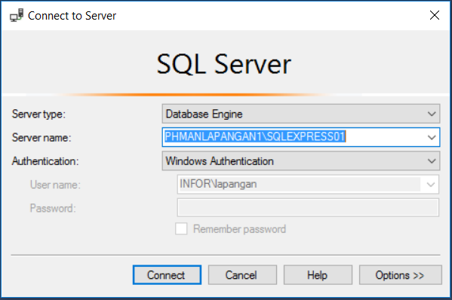
2. Right click on the Server name  
   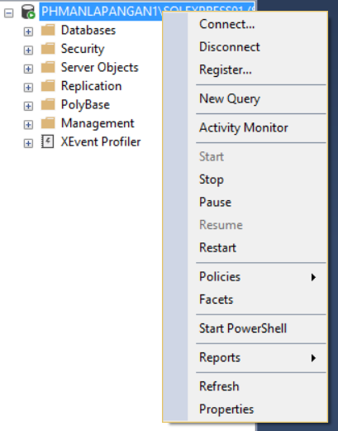
3. Click Properties
4. Go to security page.
5. Under the Server authentication, click SQL Server and Windows Authentication Mode.

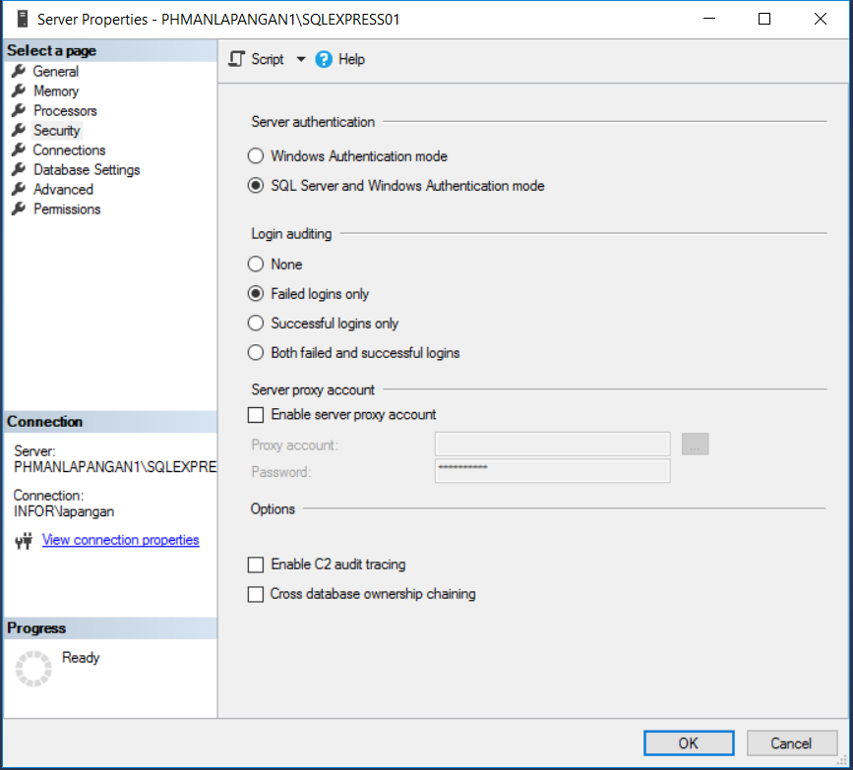

1. Click OK.
2. Press CTRL + O, then go to the location of the SQL files.
3. Choose “**00.1 CREATE Database, Login, User, Table, SP**”.
4. Click execute or press F5.
5. Repeat steps 7-9, for “**00.2 INSERT Level, Admin User**”
6. Restart computer.

Installation

# AMS

1. Go to the package location.
2. Right click on **add_firewall_inbound_rule.bat**
3. Click Run as administrator  
   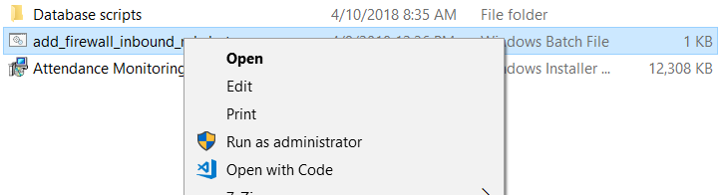
4. Run **Attendance Monitoring System.msi**

# Android Application

1. Open Google Play Store
2. Search SMS Gateway
3. Install **My SMS Gateway  
     
   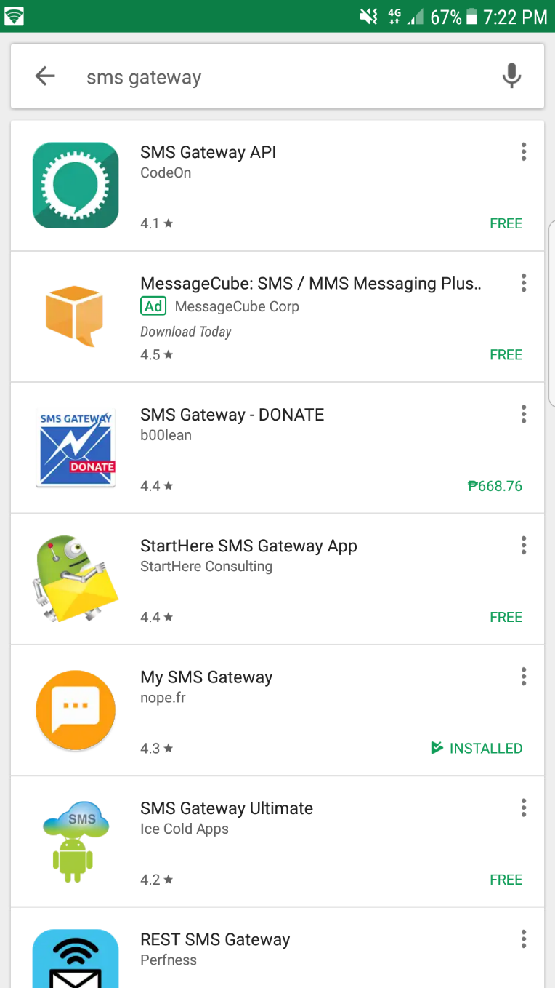**
4. Open the app
5. Tick Ack SMS Url
6. Input the SMS Service URL  
   **URL:** http://<IP_ADDRESS>:54000/SMSService/AcknowledgeSMS  
   **Note:** Replace the <*IP_ADDRESS*> with the kiosk IP address  
     
     
     
   How to get the Kiosk IP Address:  
   a. Open command prompt  
   b. Input **ipconfig**  
   c. Look for Ethernet adapter Ethernet (connected via LAN cable) or Wireless LAN adapter Wi-Fi (connected via Wifi)  
   d. Get the IPv4 Address

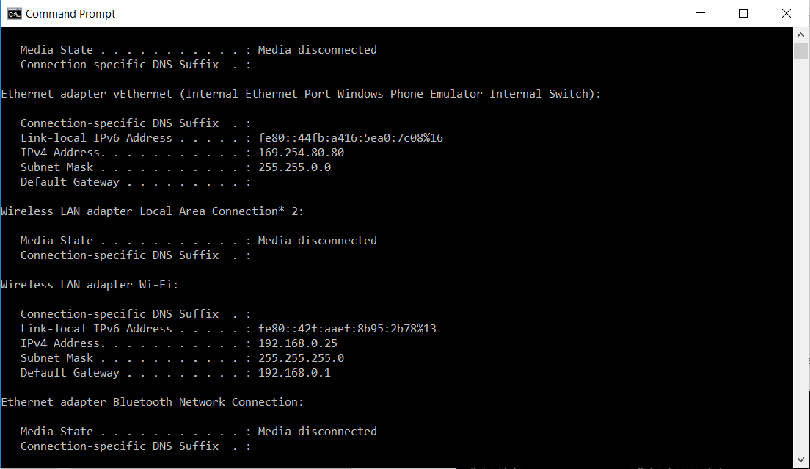

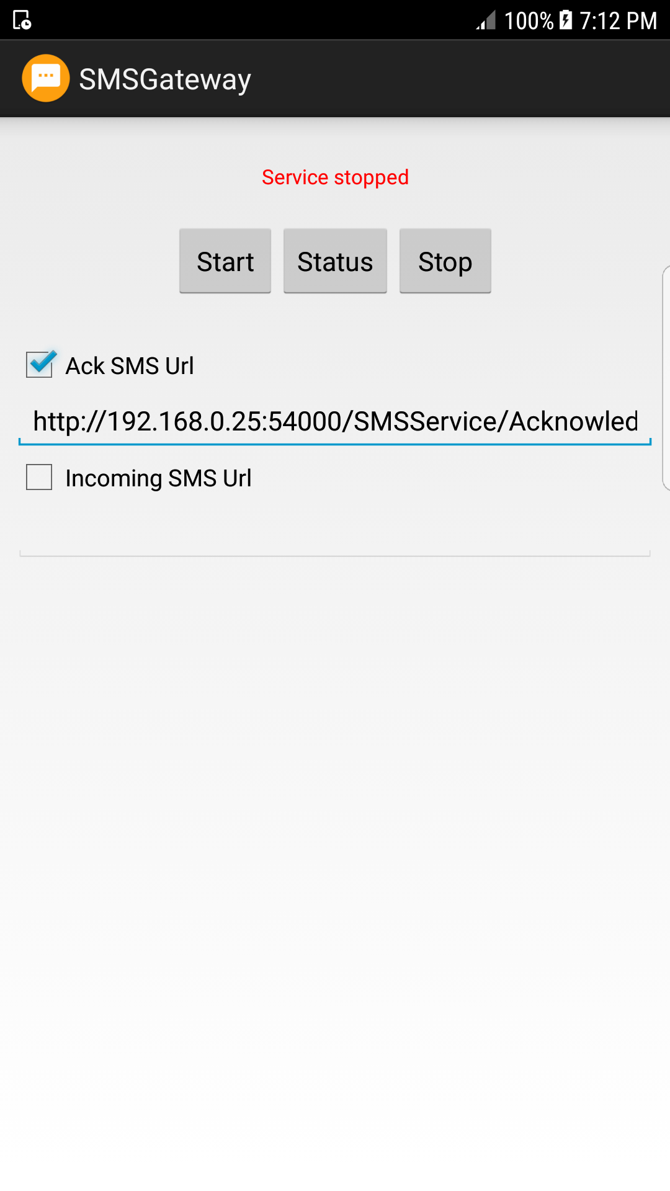

Running the Application

# Android Application

1. Open SMSGateway
2. Click Start
3. Take note of the SMS Form URL shown on the bottom part of the app.

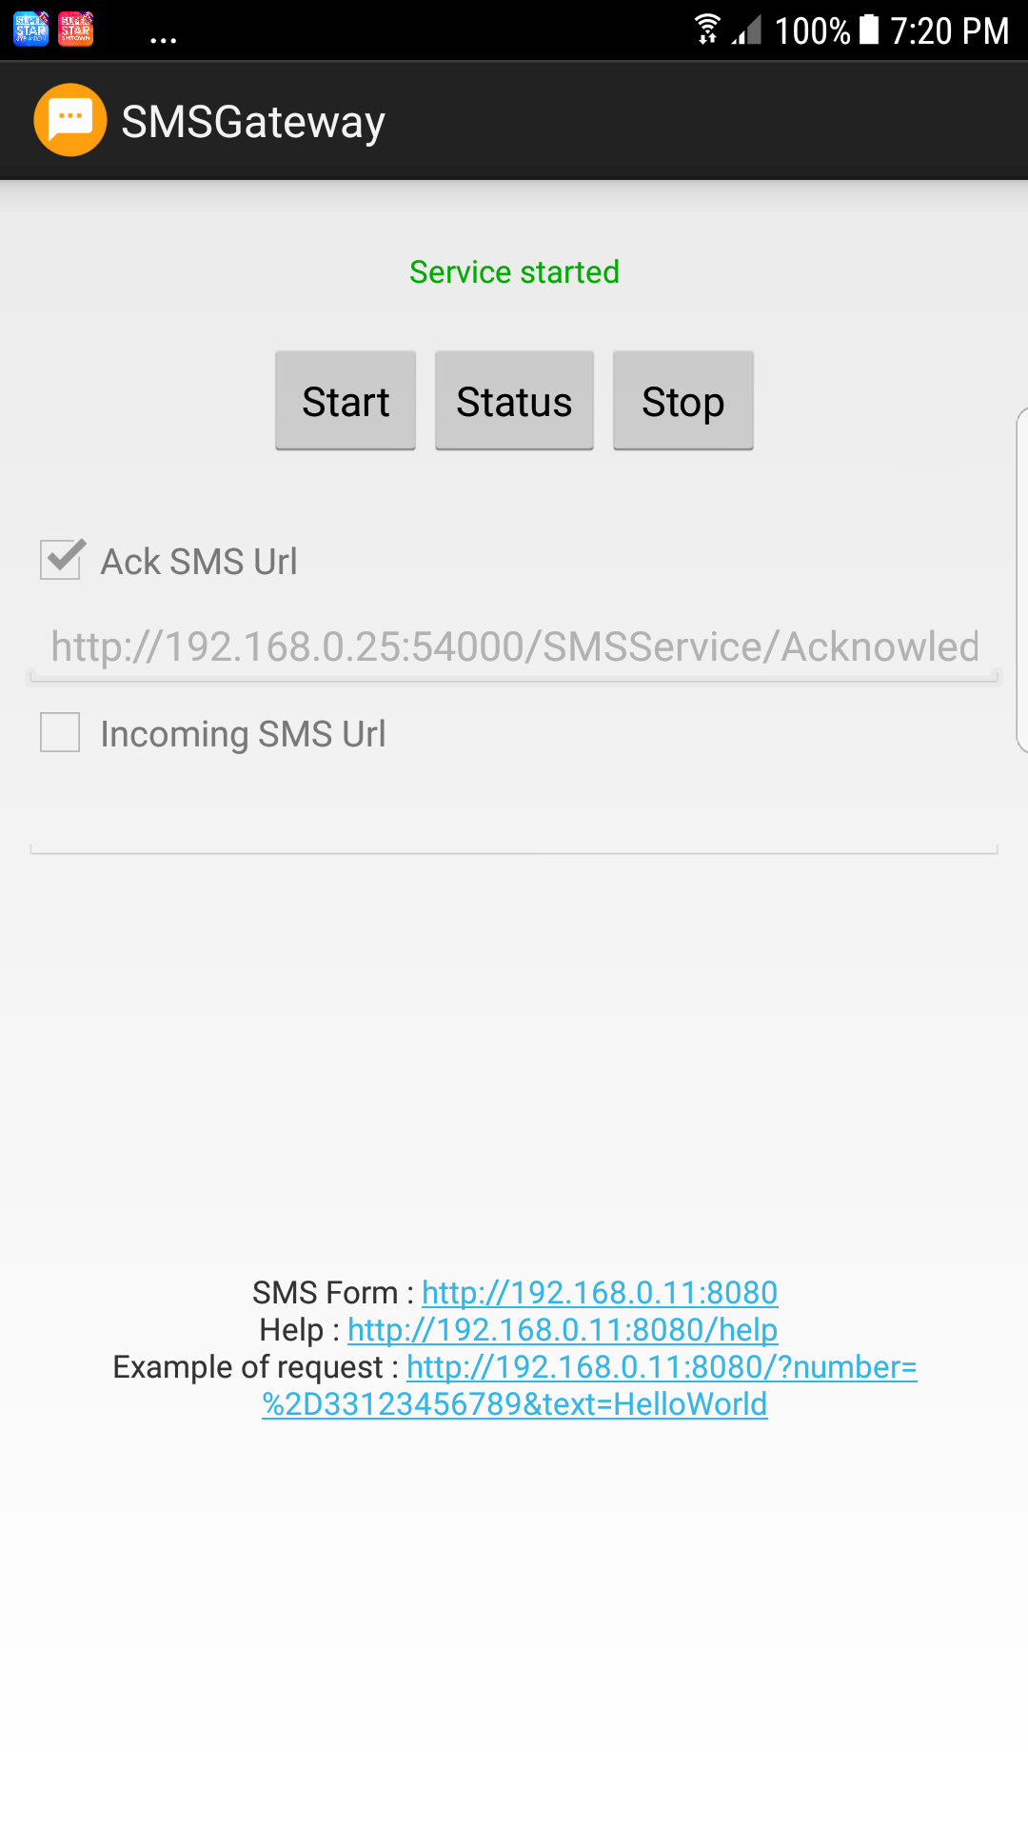

# AMS

1. Open AMS.
2. The configuration window will appear (One time setup only)  
     
   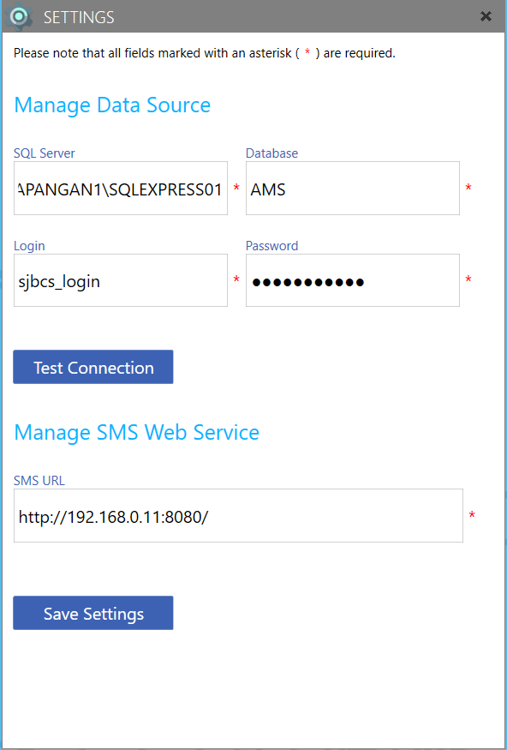
3. Input the following details:  
   **SQL Server:** Use the Server name used in opening the Microsoft SQL Server Management Studio  
   **Login:** sjbcs_login (FIXED)  
   **Password:** P@ss00word! (FIXED)  
   **SMS URL**: Use the SMS Form URL
4. Click Save settings
5. Login Screen should appear.

**Default Application Credentials**

|  |  |  |
| --- | --- | --- |
| Username | Password | type |
| admin123 | admin123 | Administrator |
|  |  |  |
| user1234 | user1234 | User |

Troubleshooting

Logs files are in “**C:\AMS\Logs**”

|  |  |
| --- | --- |
| Filename | Description |
| AMS.log | Contains warning and error logs for the main program. |
|  |  |
| SMSSErvice.log | Contains warning and error logs for the SMS service connecting the main program to the android application. |

How to check if SMS Service is running:

1. Open AMS
2. In the android phone, open any browser.
3. Type http://<IP_ADDRESS>:54000/SMSService/Test  
   **Note:** Replace the <*IP_ADDRESS*> with the kiosk IP address
4. This screen should appear.  
   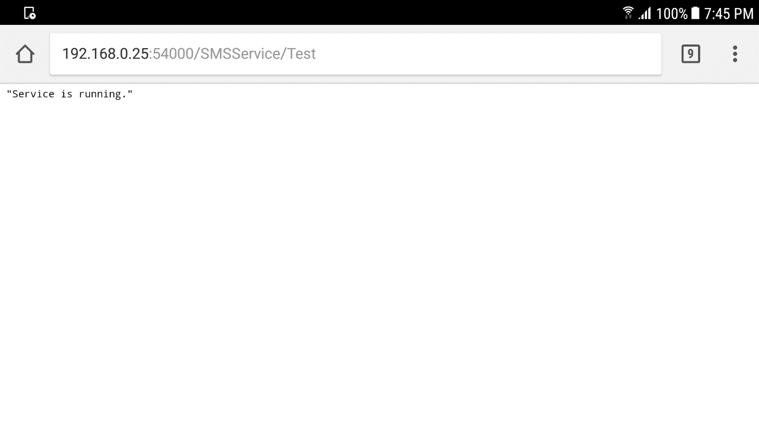

SMS is not sending:

1. Check the SMSService.log
2. Check the last error.
3. If the error is this:  
   Failed to send SMS(http://192.168.0.11:8080/): Unable to connect to the remote server  
     
   Try the following:  
   - Verify if the SMS URL is correct. Go to the SMS gateway app and check the SMS form URL.  
   - If smartphone is in locked mode, unlock the smartphone and try resending in the main program. To prevent smartphone from locking, enable “Stay awake” in the developer options and connect to cable/charger.  
   - If smartphone is not connected in network, reconnect and then try resending.  
   - If smartphone is not locked and connected to the network, open the SMS gateway app and try stopping and starting the service. Then resend.